Creating Groups from Column Values

We have the following data:

|  |  |  |
| --- | --- | --- |
| **TrID** | **Country** | **Sales** |
| T1 | India | 800 |
| T2 | UAE | 500 |
| T3 | China | 600 |
| T4 | India | 200 |
| T5 | China | 700 |
| T6 | UAE | 1800 |
| T7 | France | 200 |
| T8 | Germany | 900 |
| T9 | France | 400 |
| T10 | Germany | 300 |

Here we can understand that there are some records of Asian countries and some records of European countries. We can group those records in each of the category.

The final expected output will be as shown next 🡪

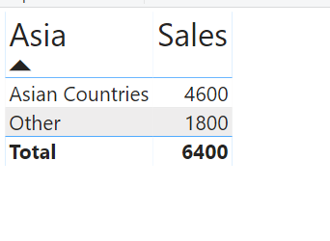

Steps:

1. In the Table view select the Country Column.
2. Select the Modeling tab
3. Click on New group icon as shown next 🡪

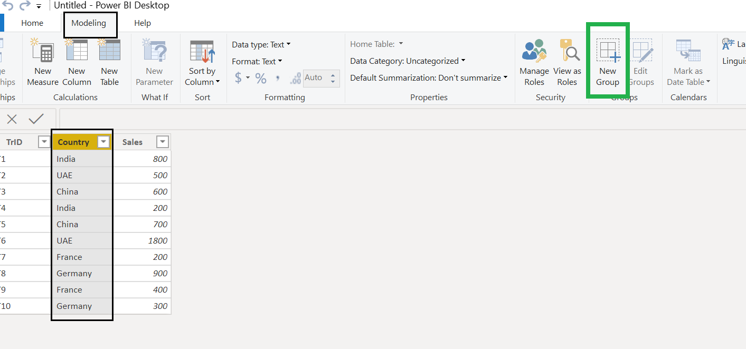

1. Give name as Asia
2. Select China, press Control and Select India and UAE
3. Click on **Group** button
4. Provide the internal name as Asian Countries
5. Select the check box **Include Other group** and then click on Ok button as shown next

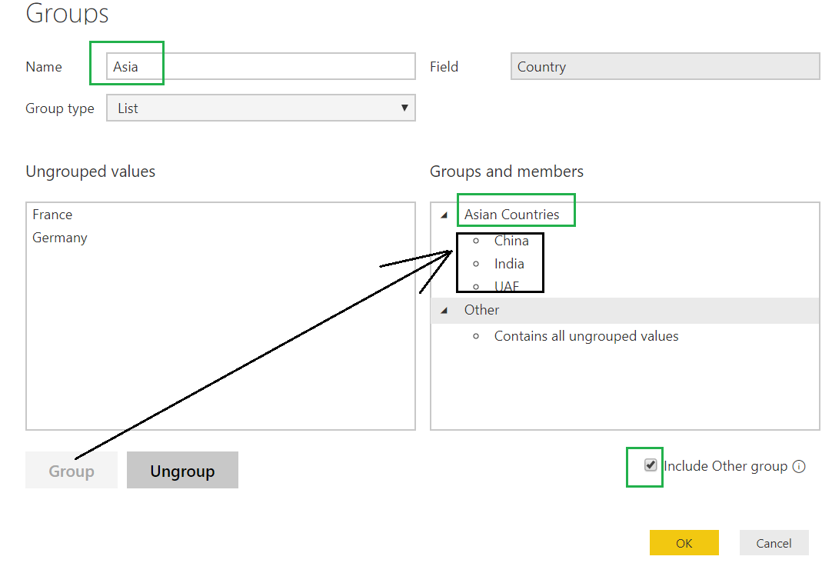

A new column gets created as shown next 🡪

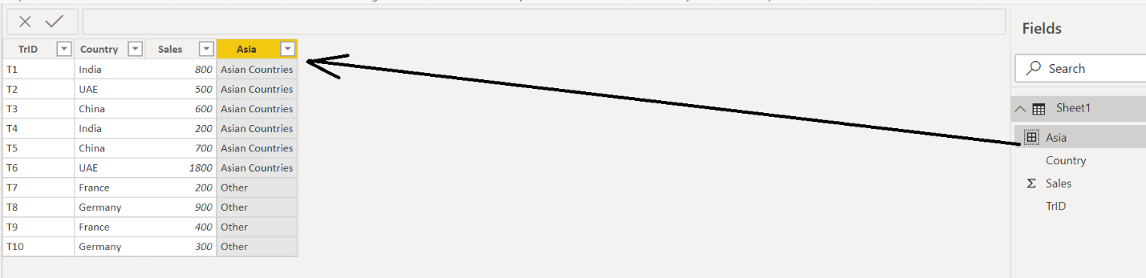

1. Now select the Report section.
2. Put a Table
3. Put Asia and Sales into it. Following look will be there:

